**Assignment 1: Creating Database Tables using MySQL**

**Tables:**

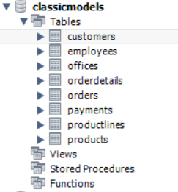

**Sample data from each table (table name at bottom left):**

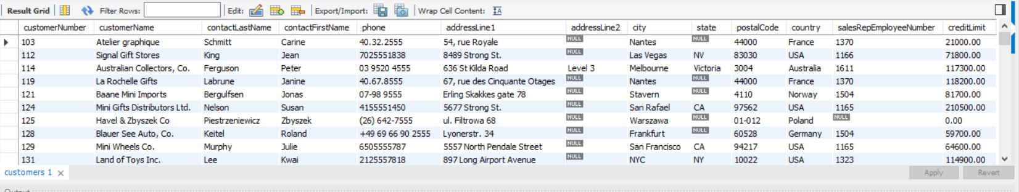

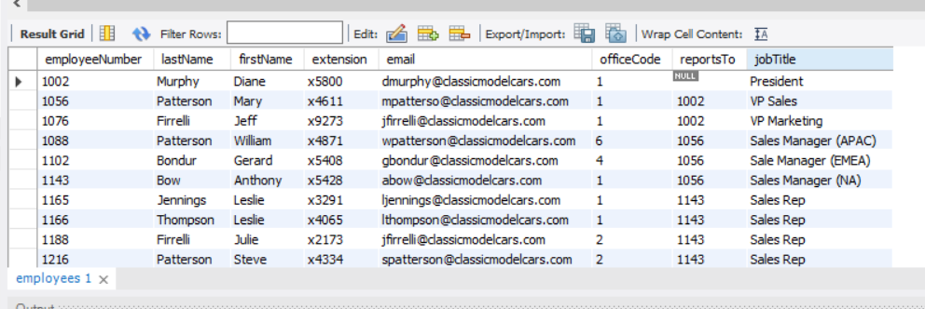

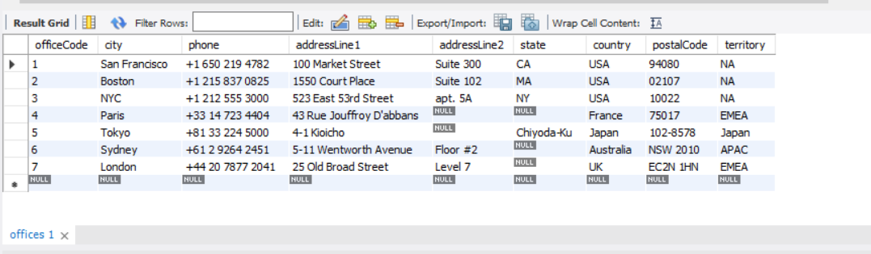

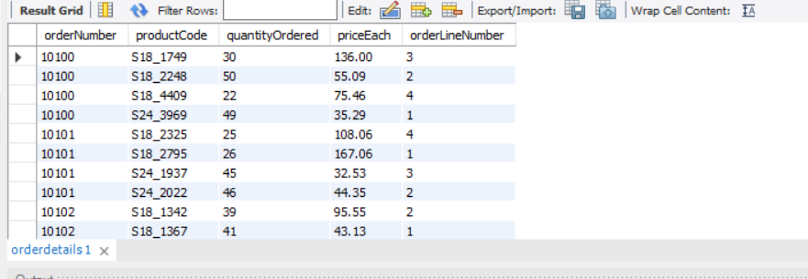

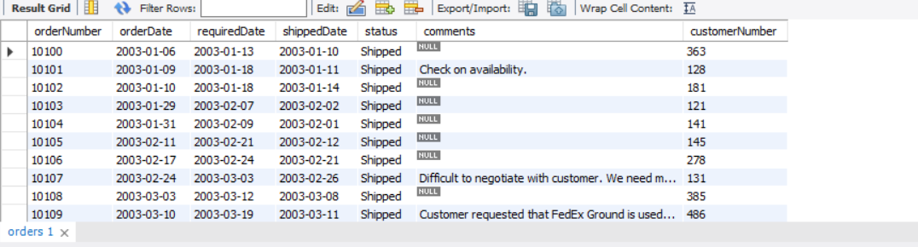

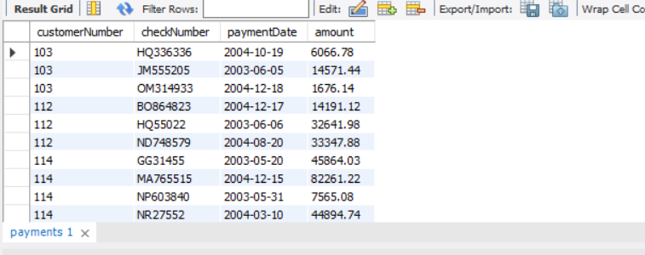

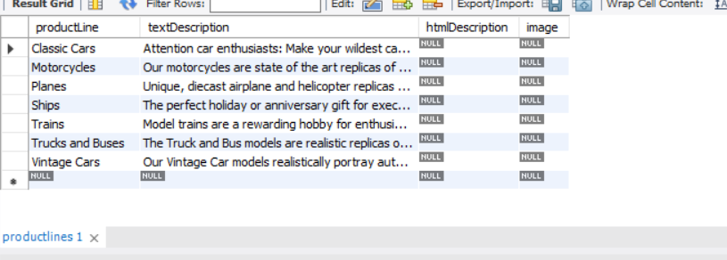

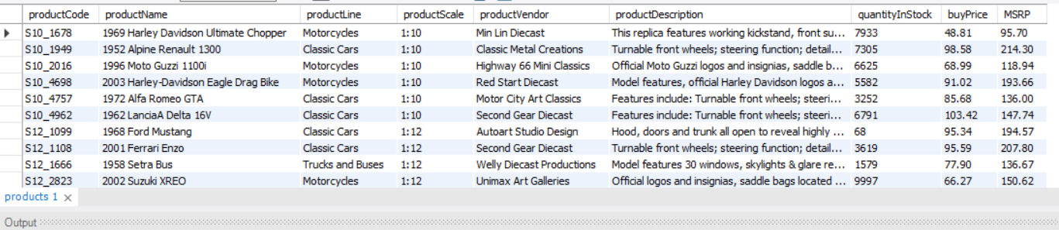

**Queries:**

1 .Find the last name of employee whose job title is ‘VP Sales’.

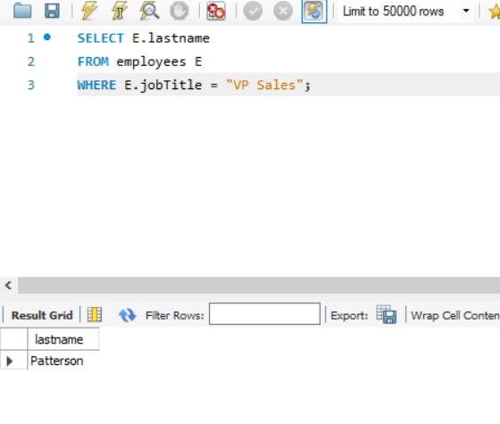

2. Find the names of employees (last name, first name) whose offices are in ‘San Francisco’.

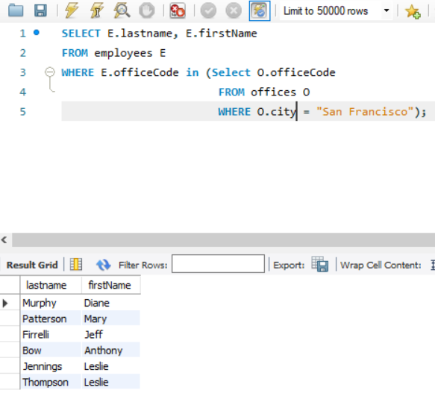

3. Find the names of customers (last name, first name) who purchased ‘Classic Cars’ according to the productLine feature of the products.

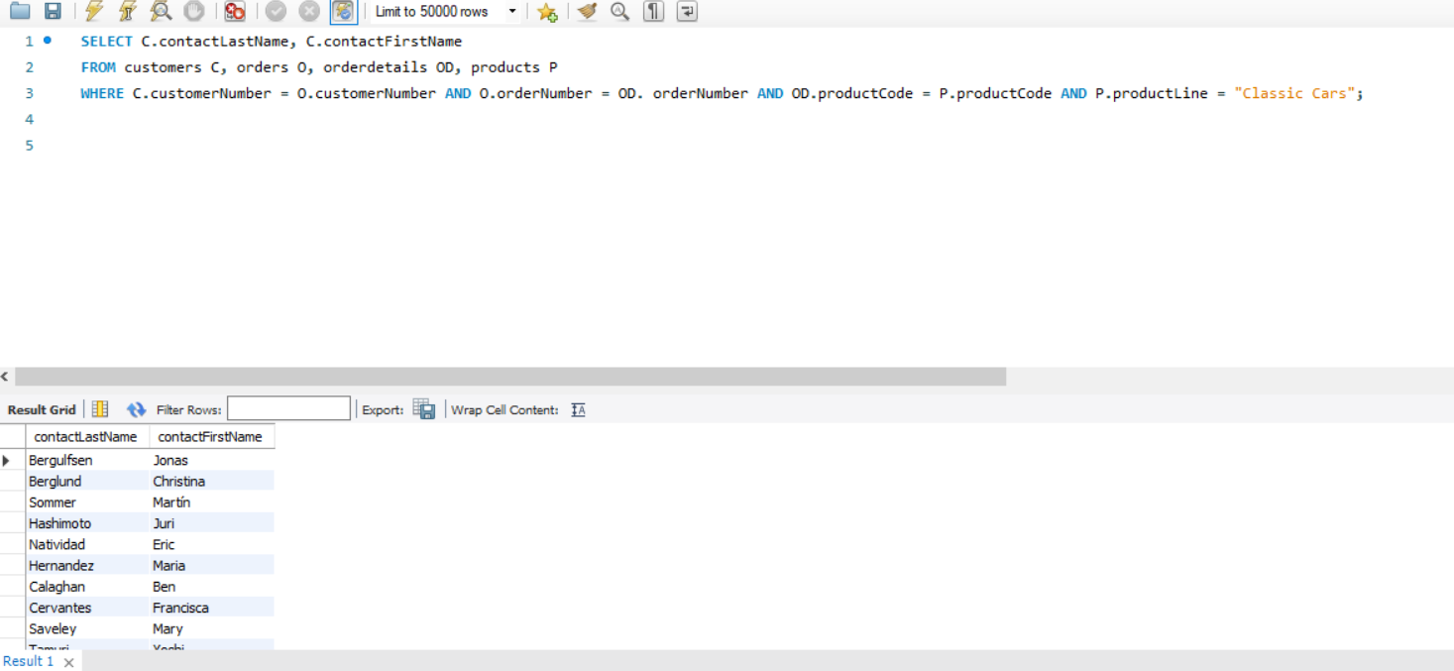

4. Find the productName of products which has the highest MSRP price.

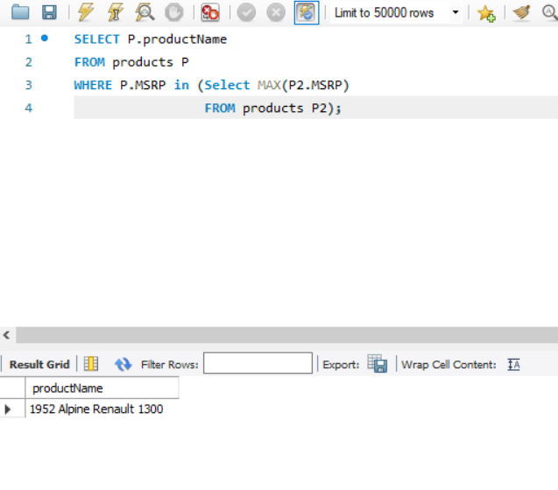

5. Find the last names of the customers who have made 5 or more payments.

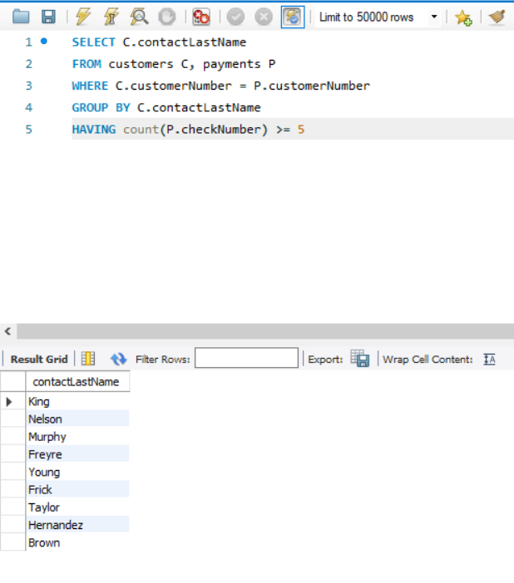

6. Find the most popular productLine (which means that it was purchased the most (maximum number of orders)).

